**WORKSHEET-3**

**SQL (Solutions)**

**ANS 1)**

create table Customers(

customerNumber int NOT NULL PRIMARY KEY,

customerName varchar(25) NOT NULL,

contactLastName varchar(10) NOT NULL,

contactFirstName varchar(15) NOT NULL,

phone varchar(15) NOT NULL,

addressLine1 varchar(30) NOT NULL,

addressLine2 varchar(30),

city varchar(20) NOT NULL,

state varchar(20) NOT NULL,

postalCode int NOT NULL,

country varchar(20) NOT NULL,

salesRepEmployeeNumber int NOT NULL,

creditLimit float NOT NULL

);

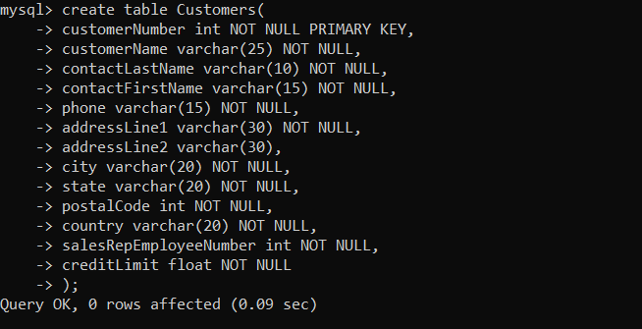

**ANS 2)**

create table Orders(

orderNumber int NOT NULL PRIMARY KEY,

orderDate DATE NOT NULL,

requiredDate DATE NOT NULL,

shippedDate DATE ,

status varchar(10) NOT NULL,

comments varchar(25) NOT NULL,

customerNumber int NOT NULL

);

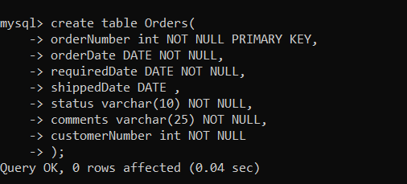

**ANS 3)** Select * from Orders;

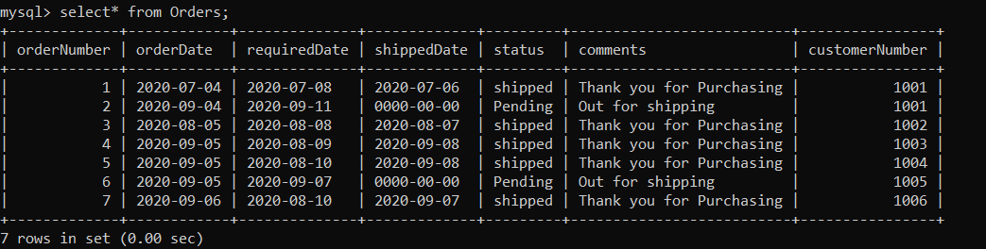

**ANS 4)** Select comments from Orders;

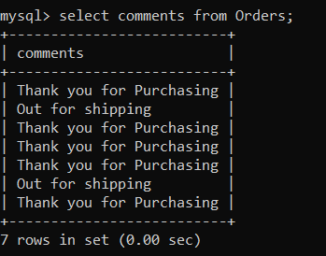

**ANS 5)**

select count(orderNumber) as Total_orders, orderDate from Orders group by orderDate;

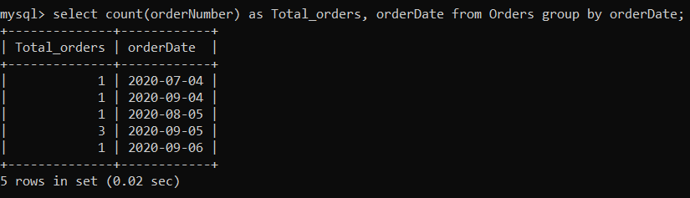

**ANS 6)**

create table employees(

employeeNumber int NOT NULL PRIMARY KEY,

lastName varchar(10) NOT NULL,

firstName varchar(10) NOT NULL,

extension varchar(25),

email varchar(25) NOT NULL,

officeCode int NOT NULL ,

reportsTo varchar(25) NOT NULL,

jobTitle varchar(20) NOT NULL

);

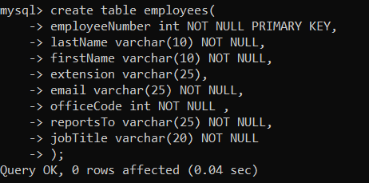

Select employeeNumber, lastName, firstName from employees;

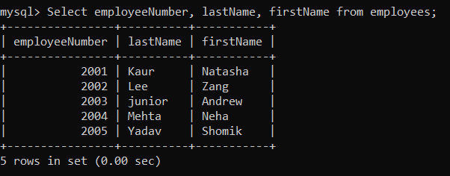

**ANS 7)** select orderNumber, customerName from customers LEFT JOIN orders ON Customers.customerNumber=orders.customerNumber;

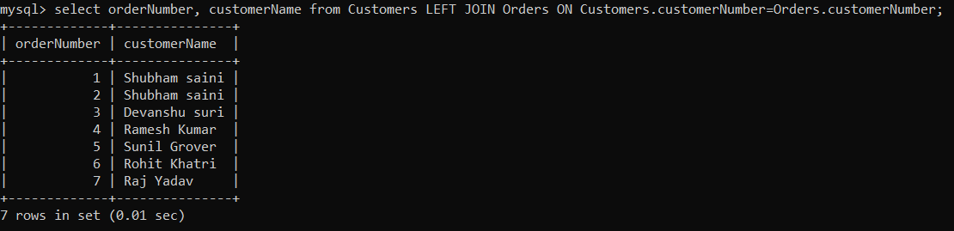

**ANS 8)** select customerName, CONCAT(lastName, firstName) from employees LEFT JOIN Customers ON Customers.salesRepEmployeeNumber=employeeNumber;

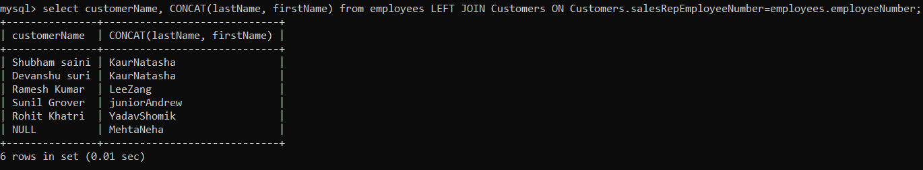

**ANS 9)**

create table payments(

customerNumber int NOT NULL,

checkNumber int NOT NULL,

paymentDate DATE NOT NULL,

amount float NOT NULL

);

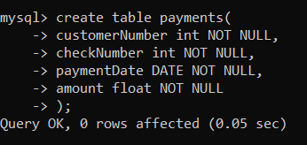

Select paymentDate, sum(amount) from payments group by paymentDate;

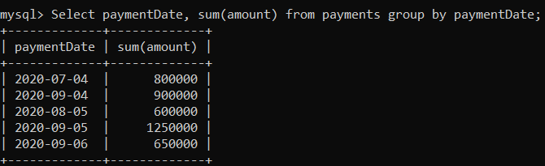

**ANS 10)**

create table products(

productCode varchar(15) NOT NULL,

productName varchar(20) NOT NULL,

productLine varchar(15) NOT NULL,

productScale int NOT NULL,

productVender varchar(20) NOT NULL,

productDescription varchar(40) NOT NULL,

quantityinStock int NOT NULL,

buyPrice float NOT NULL,

MSRP float NOT NULL

);

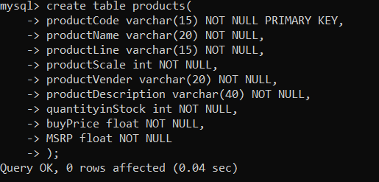

Select productName, MSRP, productDescription from products;

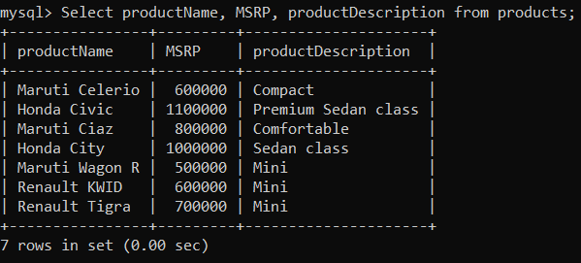

**ANS 11)** select productCode, productName,count(productName) from products group by productName limit 1;

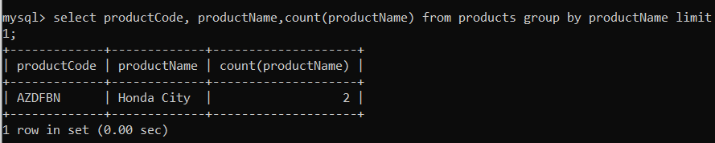

**ANS 12)** select city from customers LEFT JOIN orders ON customers.customerNumber = orders.customerNumber order by orderNumber desc limit 1;

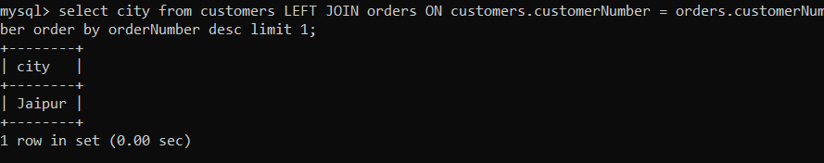

**ANS 13)** select state from customers LEFT JOIN orders ON customers.customerNumber = orders.customerNumber order by orderNumber desc limit 1;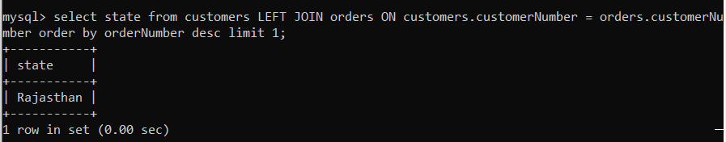

**ANS 14)** select employeeNumber, CONCAT(firstName,’ ‘, lastName) AS Full_Name

from employees;

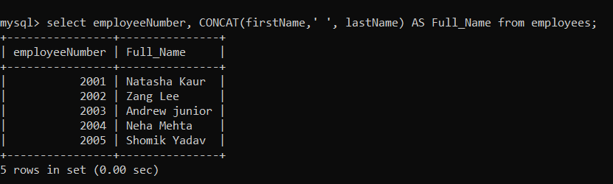

**ANS 15)** select orderNumber, customerName, amount from customers LEFT JOIN orders ON customers.customerNumber=orders.customerNumber LEFT JOIN payments ON customers.customerNumber=payments.customerNumber order by customerNumber;

